Christmas Eve Candlelight Service, December 24, 2025
Peace Lutheran Church, MN

WELCOME

HYMN 376 (Maroon): Once in Royal David’s City – Solo on verse 1

Invocation
In the name of the Father, and of the Son, and of the Holy Spirit. Amen.

Lighting the Advent Candles and the Christ Candle
3:00pm McKimm family; 5:00 Pfau family; 7:00 Peterson family

We gather together on this holy night to celebrate the birth of God’s one and only Son: Jesus, Emmanuel, Wonderful Counselor, Mighty God, Everlasting Father, Prince of Peace.

Where there is despair, Jesus brings us hope—the hope of Christmas.
Psalm 33:20 “We wait in hope for the Lord; he is our help and our shield.”
As we gather to worship: We light the candle of HOPE. (Light a blue candle.)

Where there is war and discord, Jesus brings us peace—the peace of Christmas.
Psalm 29:11 “The Lord gives strength to His people; the Lord blesses His people with peace.”
As we gather to worship: We light the candle of PEACE. (Light a blue candle.)

Where there is sorrow, Jesus brings us joy—the Joy of Christmas.
Philippians 4:4 “Rejoice in the Lord always, again I say, rejoice!”
As we gather to worship: We light the candle of JOY. (Light the pink candle.)

Where there is despair, Jesus brings us love—the love of Christmas.
John 3:16 “For God so loved the world, that He gave His only Son, that whoever believes in Him should not perish but have eternal life.”
As we gather to worship: We light the candle of LOVE. (Light a blue candle.)
Where there is darkness, Jesus brings us light—the light of Christmas.
John 8:12 Jesus spoke to them, saying, “I am the light of the world. Whoever follows me will not walk in darkness, but will have the light of life.”
As we gather to worship:
We light the Christ Candle. Jesus is the light of the world! (Light the Christ candle.)

Hymn 380 Hark! The Herald Angels Sing

Confession and Absolution

As we gather in joy and celebration, let us confess our sins
and receive the joy of being reconciled to God through His Son.

The people who walked in darkness have seen a great light.
We come this evening confessing our need and desire for the one true Light.
We are burdened by our sins and the darkness around us.
O Holy Child of Bethlehem, forgive us and enlighten us by Your grace that we may forever praise and worship You, with the angels, and with all of creation.
As a called and ordained servant of Christ, and by His authority, I forgive you all your sins in the name of the Father and of the Son and of the Holy Spirit. Amen.

HYMN 361 O Little Town of Bethlehem

OLD TESTAMENT READING: Isaiah 9:6-7
⁶ For to us a child is born,
to us a son is given;
and the government shall be upon his shoulder,
and his name shall be called
Wonderful Counselor, Mighty God,
Everlasting Father, Prince of Peace.
⁷ Of the increase of his government and of peace
there will be no end,
on the throne of David and over his kingdom,
to establish it and to uphold it
with justice and with righteousness
from this time forth and forevermore.
The zeal of the Lord of hosts will do this. (ESV)
This is the Word of the Lord. Thanks be to God!

EPISTLE READING: 1 John 4:7-12
⁷ Beloved, let us love one another, for love is from God, and whoever loves has been born of God and knows God. ⁸ Anyone who does not love does not know God, because God is love. ⁹ In this the love of God was made manifest among us, that God sent his only Son into the world, so that we might live through him. ¹⁰ In this is love, not that we have loved God but that he loved us and sent his Son to be the propitiation for our sins. ¹¹ Beloved, if God so loved us, we also ought to love one another. ¹² No one has ever seen God; if we love one another, God abides in us and his love is perfected in us. (ESV)
This is the Word of the Lord. Thanks be to God!

HYMN 367 Angels from the Realms of Glory
▲If you are able, please stand for v. 5 and remain standing for the Gospel reading.

GOSPEL READING: Luke 2:1-17
The Holy Gospel according to St. Luke, the 2nd chapter. Glory to You, O Lord.
In those days a decree went out from Caesar Augustus that all the world should be registered. ² This was the first registration when^{[a]} Quirinius was governor of Syria. ³ And all went to be registered, each to his own town. ⁴ And Joseph also went up from Galilee, from the town of Nazareth, to Judea, to the city of David, which is called Bethlehem, because he was of the house and lineage of David, ⁵ to be registered with Mary, his betrothed, who was with child. ⁶ And while they were there, the time came for her to give birth. ⁷ And she gave birth to her firstborn son and wrapped him in swaddling cloths and laid him in a manger, because there was no place for them in the inn.

⁸ And in the same region there were shepherds out in the field, keeping watch over their flock by night. ⁹ And an angel of the Lord appeared to them, and the glory of the Lord shone around them, and they were filled with great fear. ¹⁰ And the angel said to them, “Fear not, for behold, I bring you good news of great joy that will be for all the people. ¹¹ For unto you is born this day in the city of David a Savior, who is Christ the Lord. ¹² And this will be a sign for you: you will find a baby wrapped in swaddling cloths and lying in a manger.” ¹³ And suddenly there was with the angel a multitude of the heavenly host praising God and saying,
¹⁴ “Glory to God in the highest,
and on earth peace among those with whom he is pleased!”
¹⁵ When the angels went away from them into heaven, the shepherds said to one another, “Let us go over to Bethlehem and see this thing that has happened, which the Lord has made known to us.” ¹⁶ And they went with haste and found Mary and Joseph, and the baby lying in a manger. ¹⁷ And when they saw it, they made known the saying that had been told them concerning this child.
This is the Gospel of the Lord. Praise to You, O Christ.

CHILDREN’S MESSAGE

HYMN 364 (Maroon): Away in a Manger

SERMON “He Is Born in a Manger for Us” Pastor Weber

THE APOSTLES’ CREED
I believe in God, the Father Almighty, maker of heaven and earth. And in Jesus Christ, His only Son, our Lord, who was conceived by the Holy Spirit, born of the virgin Mary, suffered under Pontius Pilate, was crucified, died, and was buried. He descended into hell. The third day He rose again from the dead. He ascended into heaven and sits at the right hand of God the Father Almighty. From thence He will come to judge the living and the dead. I believe in the Holy Spirit, the holy Christian Church, the communion of saints, the forgiveness of sins, the resurrection of the body, and the life everlasting. Amen.

PRESENTATION OF OFFERINGS
Please sign the friendship pad in the pew and pass it along to others. As it is passed back to the center aisle, please take the opportunity to note the names of others seated in your pew.

PRAYERS & THE LORD’S PRAYER

CANDLE LIGHTING

Please remain seated for the candle lighting.
Pastors and ushers will light the candle of the person nearest the aisle.
Each worshiper lights his candle from his neighbor’s candle,
taking care to tip only the unlighted candle
so as to avoid dripping the hot wax.

SCRIPTURE READING, Isaiah 9:2 and 60:1-3:
The people walking in darkness have seen a great light;
on those living in the land of deep darkness a light has dawned.
Arise, shine, for your light has come,
and the glory of the Lord rises upon you.
See, darkness covers the earth
and thick darkness is over the peoples,
but the Lord rises upon you
and his glory appears over you.
Nations will come to your light,
and kings to the brightness of your dawn. (NIV)
This is the Word of the Lord. Thanks be to God.

HYMN 363 Silent Night

Stille Nacht! Heil'ge Nacht! Alles schläft; einsam wacht
Nur das traute hoch heilige Paar. Holder Knabe im lockigen Haar,
Schlafe in himmlischer Ruh! Schlafe in himmlischer Ruh!

Silent night, holy night! All is calm, all is bright
‘Round yon virgin mother and child.
Holy Infant so tender and mild
Sleep in heavenly peace, Sleep in heavenly peace.

Silent night, holy night! Shepherds quake at the sight;
Glories stream from heaven afar, Heav’nly hosts sing, “Alleluia!”
Christ, the Savior is born! Christ the Savior is born!

Silent night, holy night! Son of God, love’s pure light
Radiant beams from Thy holy face, With the dawn of redeeming grace,
Jesus, Lord, at Thy birth, Jesus, Lord, at Thy birth

BENEDICTION
The Lord bless you and keep you. The Lord make His face shine on you and be
gracious to you. The Lord look upon you with favor and give you peace. Amen.

(Extinguish your candles and hand them to an usher when you depart.)

HYMN 387 Joy to the World

Joy to the world, the Lord is come! Let earth receive her King:
Let ev'ry heart prepare Him room And heav'n and nature sing,
And heav'n and nature sing. And heav'n, and heav’n and nature sing.

Joy to the earth, the Savior reigns! Let men their songs employ,
While fields and floods, rocks, hills, and plains Repeat the sounding joy,
Repeat the sounding joy. Repeat, repeat the sounding joy.

No more let sins and sorrows grow Nor thorns infest the ground;
He comes to make His blessings flow Far as the curse is found,
Far as the curse is found. Far as, far as the curse is found.

He rules the world with truth and grace And makes the nations prove
The glories of His righteousness And wonders of His love,
And wonders of His love. And wonders, wonders of His love.

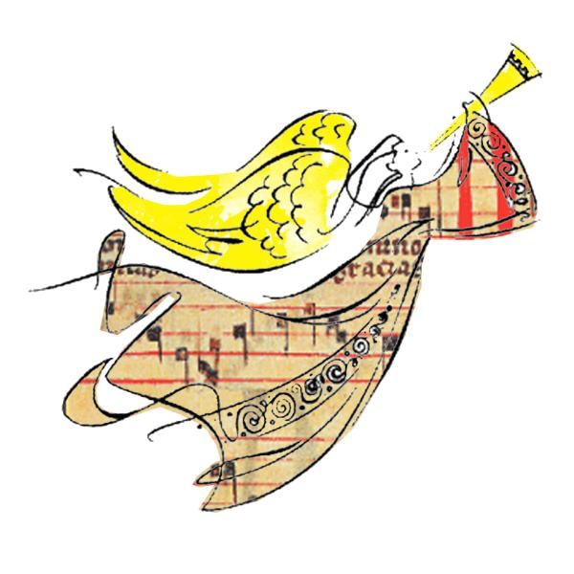

December 25th
Christmas Day Worship at 9:00am in the Sanctuary, with communion

December 28th
One service, Sunday at 10am in the Sanctuary, with communion.
No Bible study or Sunday School.

January 3-4, 2026, Epiphany
Return to normal worship schedule (6:30pm, 8:30am, 10:30am)
Installation of Elia Peterson as Director of Family, Youth and Children’s Ministry
9:30am Welcome brunch for all members:
Sunday School students and Youth, parents and teachers in the Peace Center
Please join us as we welcome Elia Peterson, DCE, to Peace!
Sunday School students sing at 10:30am.

